Feature ‐ Fine‐Tuning

How To Create a Fine-Tuned Model

Step 0: Create Fine-Tuning Project:
Open [Fine-Tuning] tab and click on [Add New] button:
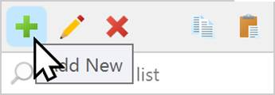
Type the fine-tuning name, for example, the company name "Doughnut Dynamics" and press enter.
Select the AI Service and AI model that are available for fine-tuning. For example, "gpt-3.5-turbo".
Type the system message with the unique company name. It will also be used as the system message of the chatbot in order for the chatbot to use the fine-tuned data.
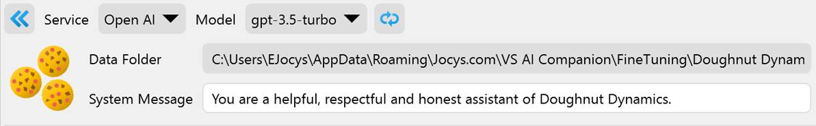

Step 1: Source Files
Open the [Source Files] tab and prepare information about your company. These types of source file formats are supported:
- JSON (*.json)
- Rich Text Format (*.rtf)
- Comma Separated Values (*.csv)
- Microsoft Excel Worksheet (*xlsx)
- Microsoft Word Document (*.docx)
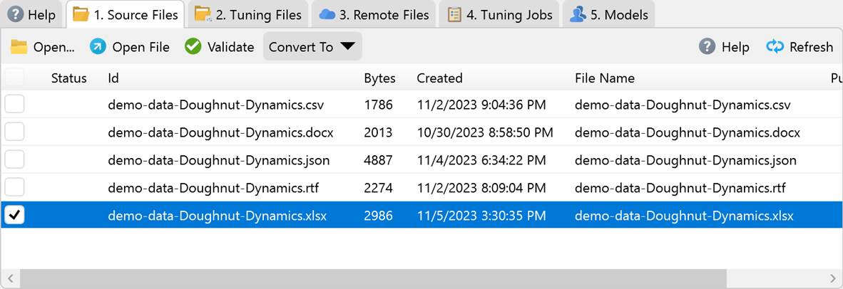
For example, if you use Excel, create two columns, "user" and "assistant". Each row can represent one customer request, prompt, or question and one company reply.
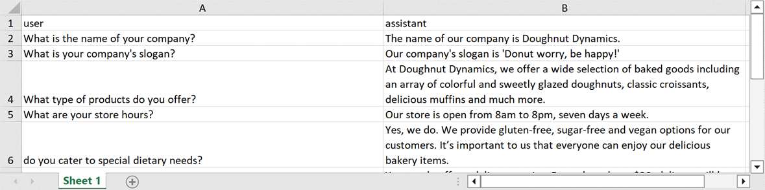
When finished, save the file and select the file.
Press the [Validate] button to check if the file format is valid.
Convert the file to "JSON Lines (*.json)" file-tuning format.
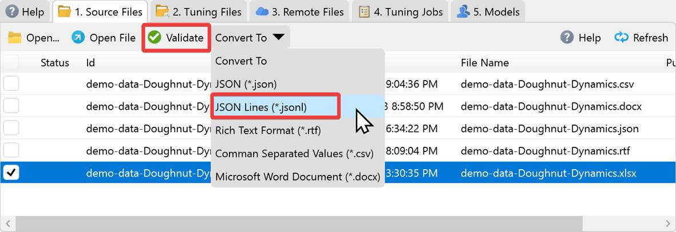

Step 2: Tuning Files
Select the JSON Lines (*.json) file.
Press the [Validate] button to check if the file format is valid.
Press the [Upload] button to upload the fine-tuning file to the AI Service via API.
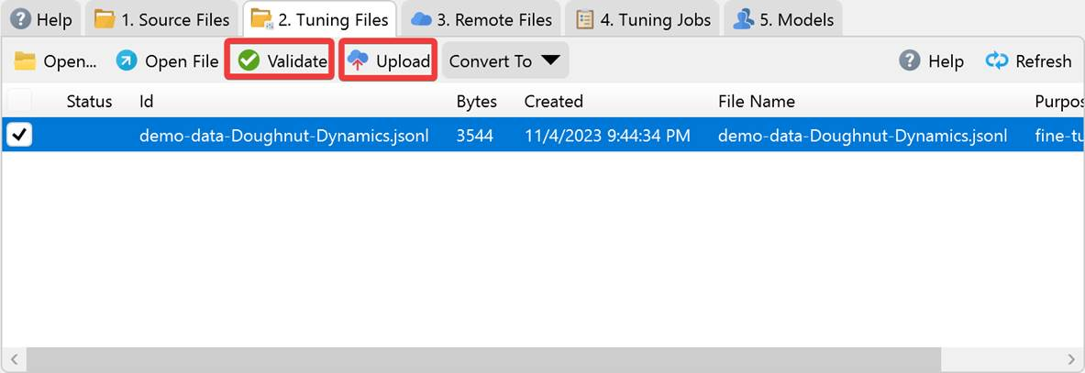

Step 3: Remote Files
Once the upload is done, select the [Remote Files] tab.
Press the [Create a Job and Model from File] button. This will create a job that will fine-tune your custom AI model from the supplied data. It can take from 5 minutes to a while, depending on the amount of data. If you are using a commercial service, don't forget to check the pricing.
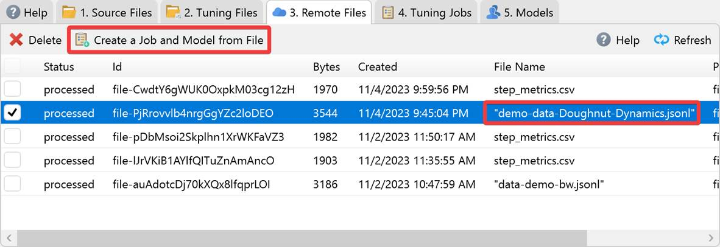

Step 4: Tuning Jobs
Wait until the job succeeds or fails. If the fine-tuning job is successful, then you can switch to the next tab.
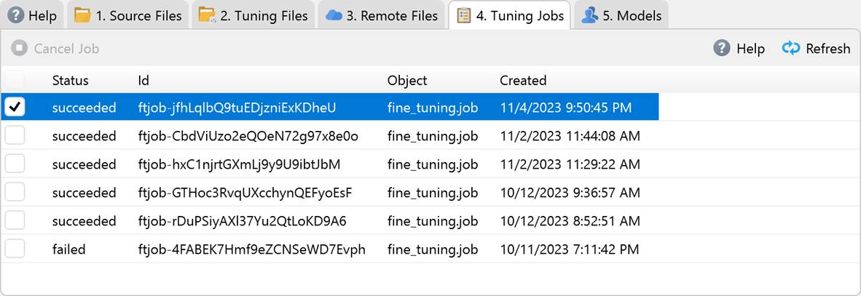

Step 5: Models
If the job is successful, then a new custom model will be created on [Models] tab.
Select the custom model.
Press the [Create and Assistant Task from Model] button.
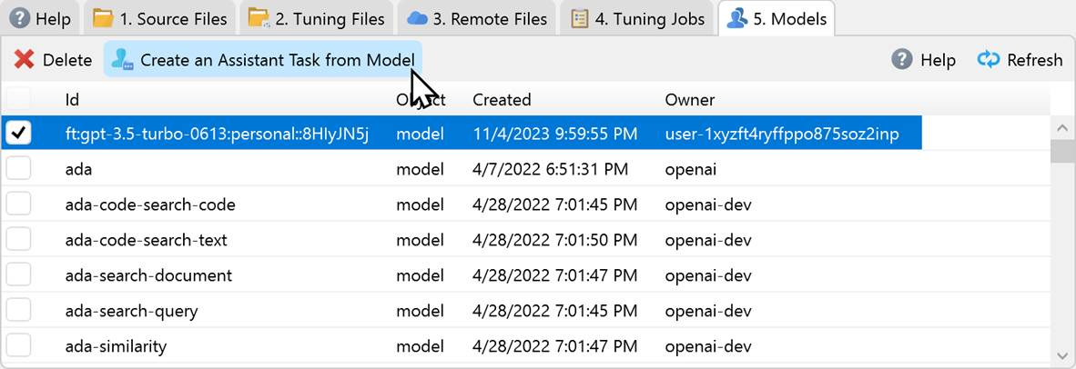

Step 6: Chat with the Chatbot (Virtual Employee)
You can start chatting with the company's virtual assistant. You can create different chats with custom prompts in order to customize your virtual employee.
